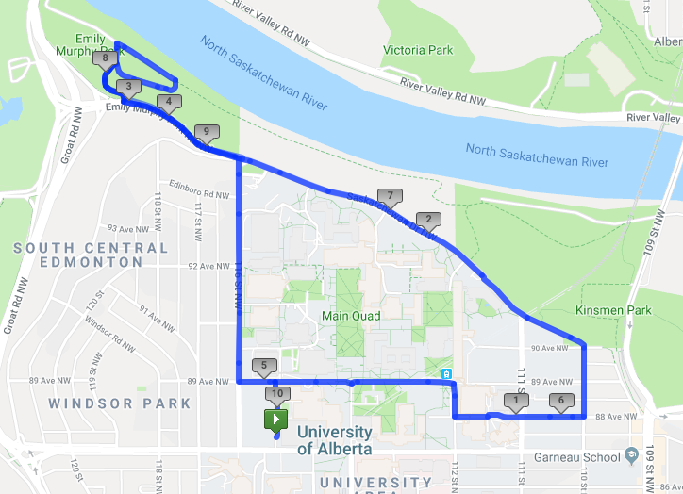

A

J

E

G

H

1st WATER STATION

POLICE

2nd WATER STATION

F

D

C

B